Lab 6 CCS3101
16 May 2025
- Solve the following questions and demonstrate your solutions to me in this lab, the next lab (preferred) or at the start of the lab after next. This is a 2-weeks lab. For record-keeping, submit also your solutions and screenshots of their output to PutraBlast.
- Evaluation will be done according to the lab rubric on PutraBlast. I will ask questions accordingly.
*******************************

Questions:

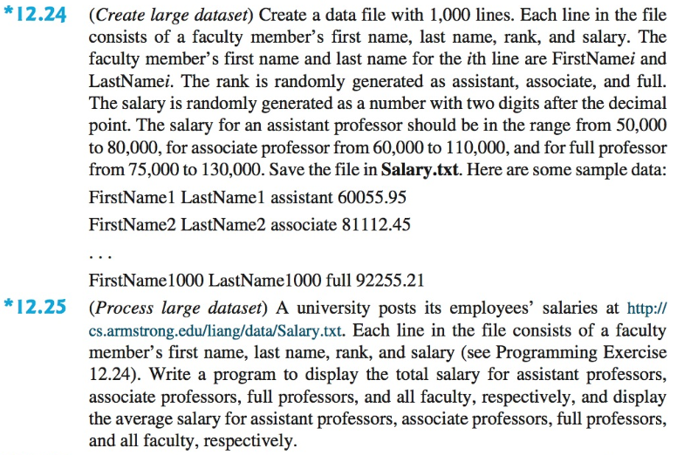

Correction: For Question 12.25, replace the URL in the question with https://liveexample.pearsoncmg.com/data/Salary.txt .

I suggest that you do Question 12.25 before Question 12.24.

(The questions are from the 10th edition of the Liang textbook. The corresponding questions in the 11th edition are the same, as far as I know, except for the URL in Question 12.25).

